Project: Implementing microservices with Code Pipeline and ECS

Course-end Project 2
Description
Objective
The objective of this project is to showcase the end-to-end process of deploying a microservices-based application with separate Backend (NodeJS) and Frontend (React) services using AWS CodePipeline and Amazon ECS. This project demonstrates the automation of CI/CD workflows, efficient containerization of both backend and frontend applications, and the deployment of these services on a scalable ECS cluster. The setup ensures high availability, seamless updates, and a reliable architecture utilizing serverless containers with AWS Fargate.
Problem Statement and Motivation
Real-time scenario:
DevBank, a rapidly expanding financial technology company, offers a digital banking platform to clients across North America. To enhance scalability and handle increasing user transactions, DevBank is transitioning its backend services (NodeJS API) and frontend interface (React application) to a microservices architecture deployed on AWS.
As a DevOps Engineer at DevBank, you are tasked with implementing automated CI/CD pipelines for both backend and frontend services. This project involves using Docker for containerization, AWS CodePipeline for automating builds, and Amazon ECS with AWS Fargate for deploying the services in a serverless, high-availability setup. Your responsibility is to ensure an efficient, automated deployment process that reduces release time and maintains a seamless user experience, enabling DevBank to scale its platform and deliver reliable services to its growing customer base.

Repositories
- ReactFrontend
- NodeBackend

Frontend buildspec.yml
version: 0.2

phases:
pre_build:
commands:
- echo Logging in to DockerHub...
- echo $DOCKERHUB_PASS | docker login -u $DOCKERHUB_USER --password-stdin
- REPOSITORY_URI="docker.io/pradeepviswa/capstonefrontend"
- CONTAINER_NAME="frontend-container"
- IMAGE_TAG="latest"
build:
commands:
- echo Build started on `date`
- echo Building the Docker image...
- docker build -t $REPOSITORY_URI:$IMAGE_TAG .
post_build:
commands:
- echo Build completed on `date`
- docker push $REPOSITORY_URI:$IMAGE_TAG
- echo Writing image definitions file...
- printf '[{"name":"'$CONTAINER_NAME'","imageUri":"%s"}]' $REPOSITORY_URI:$IMAGE_TAG > imagedefinition.json
artifacts:
files: imagedefinition.json

Backend buildspec.yml
version: 0.2

phases:
pre_build:
commands:
- echo Logging in to DockerHub...
- echo $DOCKERHUB_PASS | docker login -u $DOCKERHUB_USER --password-stdin
- REPOSITORY_URI="docker.io/pradeepviswa/capstonebackend"
- CONTAINER_NAME="backend-container"
- IMAGE_TAG="latest"
build:
commands:
- echo Build started on `date`
- echo Building the Docker image...
- docker build -t $REPOSITORY_URI:$IMAGE_TAG .
post_build:
commands:
- echo Build completed on `date`
- docker push $REPOSITORY_URI:$IMAGE_TAG
- echo Writing image definitions file...
- printf '[{"name":"'$CONTAINER_NAME'","imageUri":"%s"}]' $REPOSITORY_URI:$IMAGE_TAG > imagedefinition.json
artifacts:
files: imagedefinition.json

AWS Login
Region: us-east-1
AWS VPC
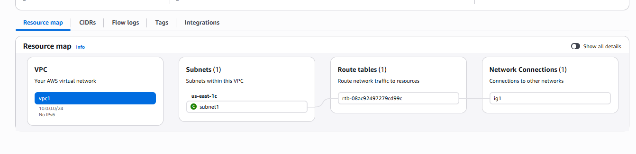

ECS Cluster
Name: vibrant-lion-otuntq (use the default generated name)
Infrastructure: Fargate Only (Serverless)
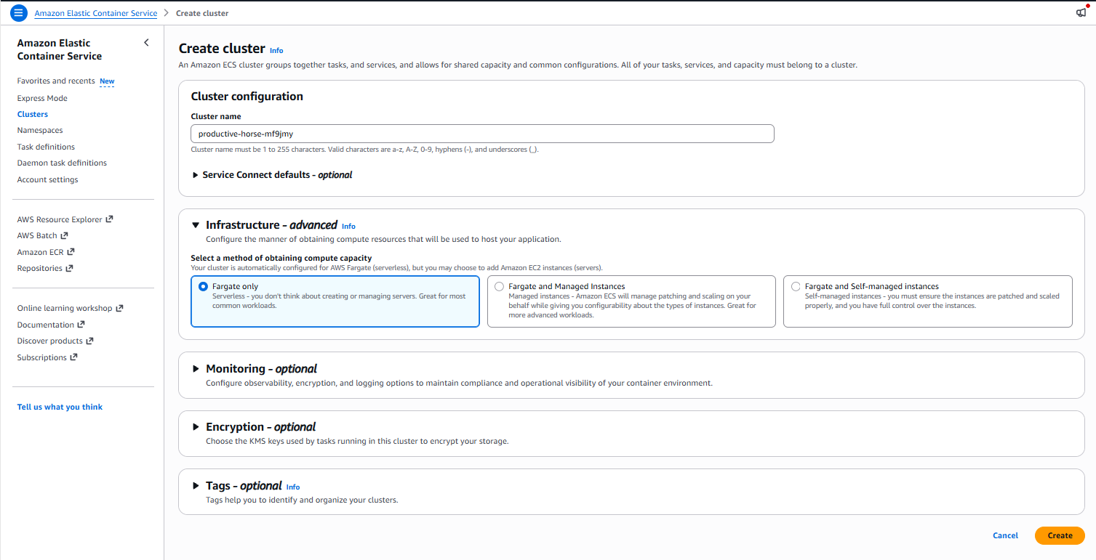

Create Task Definitions
Amazon Elastic Container Service > Task definitions
Create task definition for both frontend and backend:
- container-port should be set to 3000
- Container Detail:
  - For Frontend:
    - Name: frontend-container
    - URI: docker.io/pradeepviswa/capstonefrontend:latest
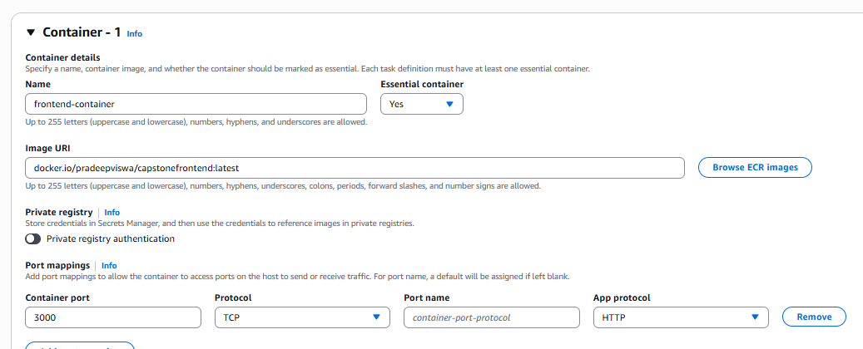
  - For Backend:
    - Name: backend-container
    - URI: docker.io/pradeepviswa/capstonebackend:latest
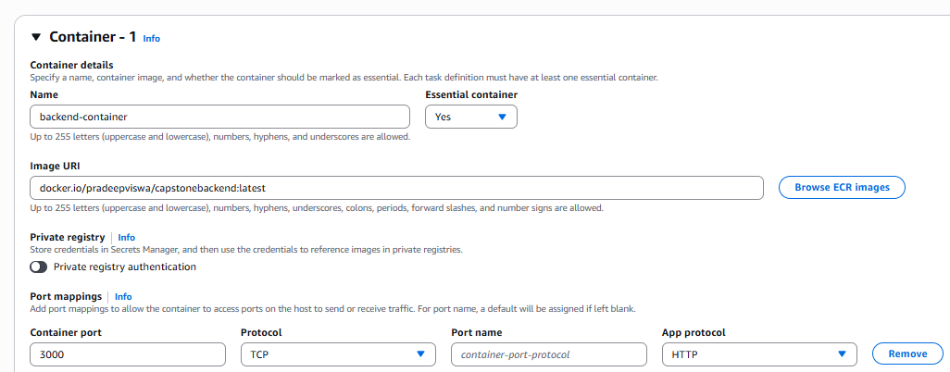

Create ECS Service
Go to cluster (vibrant-lion-otuntq) > service
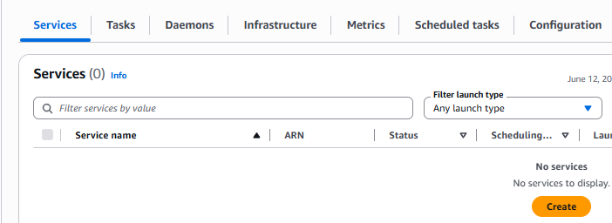
Create Service for both frontend and backend:
- choose the task definition Family
- Networking
  - Choose the previously created VPC
  - Choose all the public subnet
  - create new security group
  - inbound rule
    - Type = Custom TCP
    - Port range = 3000
    - Source = Anywhere

  - Note: you need to create the Security group only once, when you create the first service. Reuse the group in second service

Frontend service
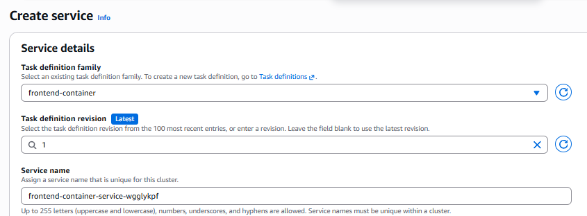
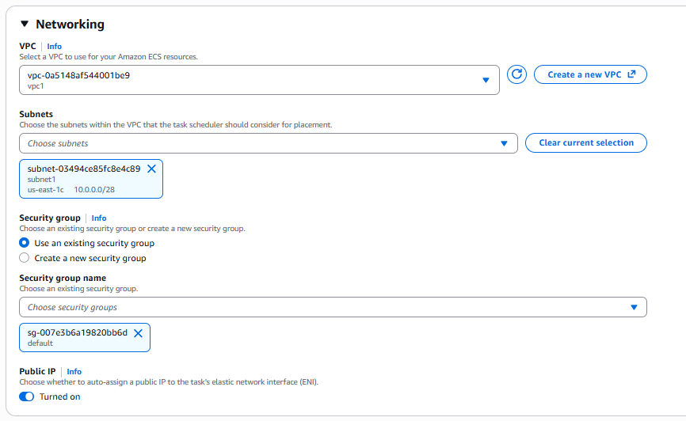

Backend Service
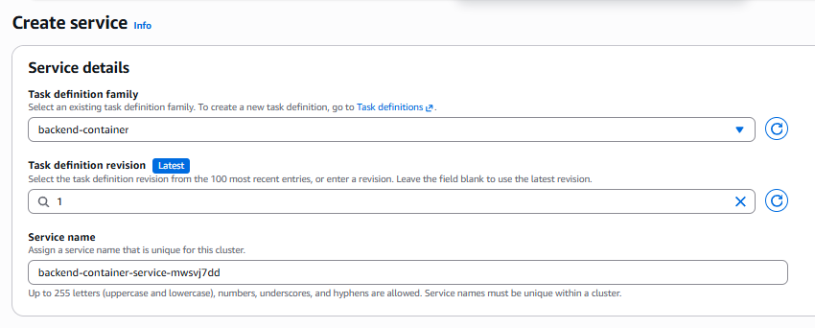
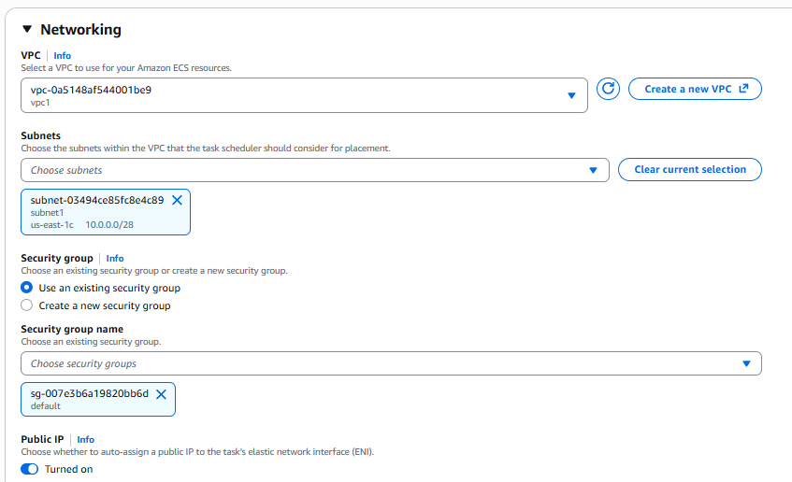

Service list
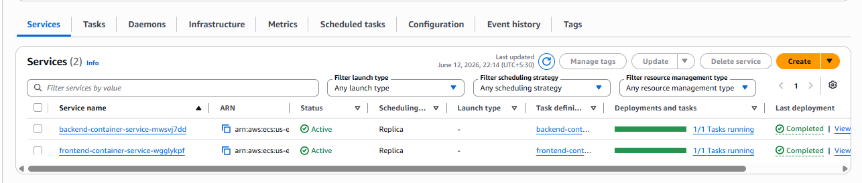

Setup CodePipeline
Create two pipelines : FrontendPipeline and BackendPipeline

Source stage

Create Code pipeline for Backend
Developer Tools > CodePipeline > Pipelines > Create new pipeline > build custom pipeline
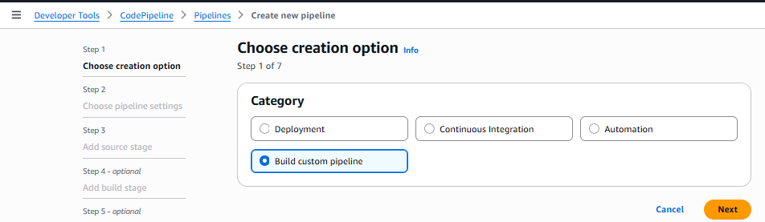

Pipeline settings
Name: FrontendPipeline
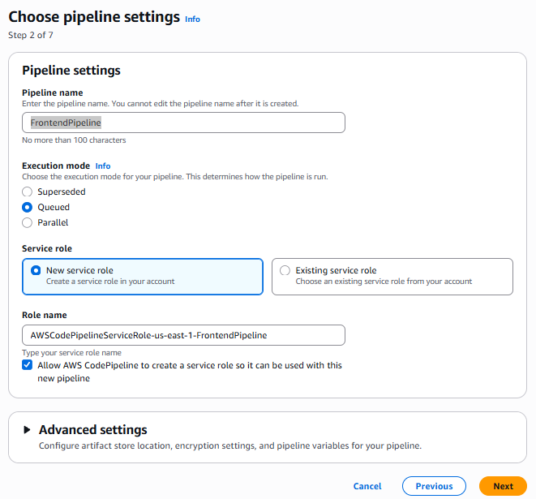

Source
Github (via OAuth app) > connect to Github
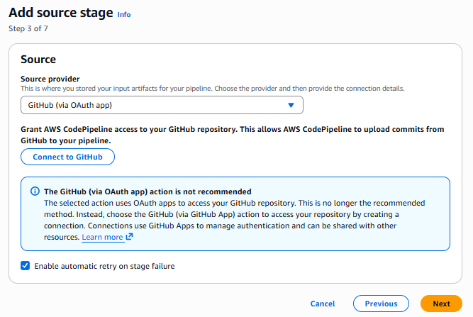

Connect with github
Authenticate
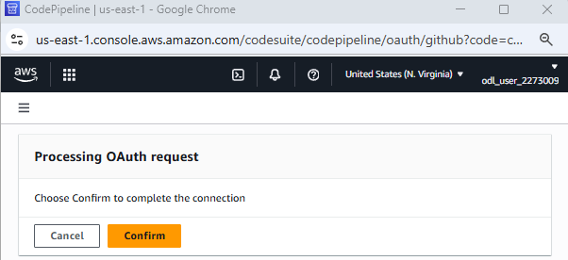

Select repository and branch
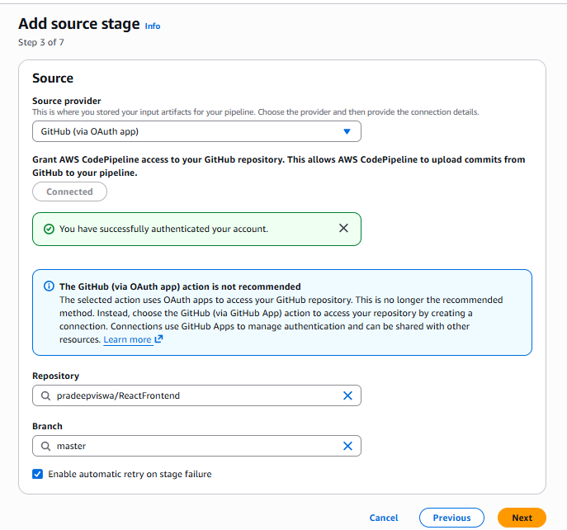

Build
Build provider: Other build provider
AWS CodeBuild
Create Project
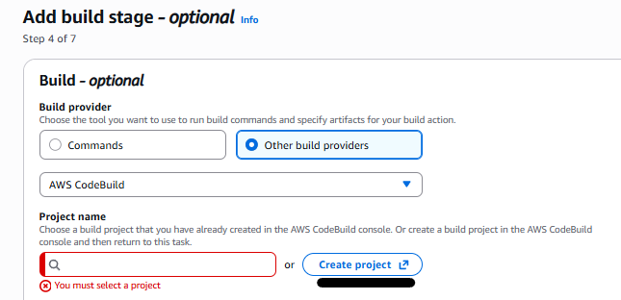

Project name: frontendProject
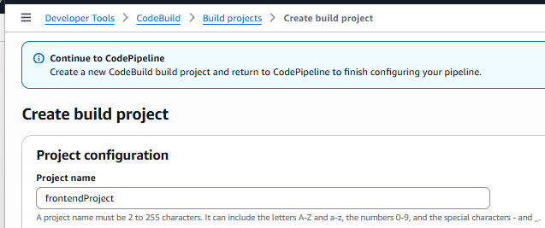

add two environment variables under “Additional configuration”:
    - “DOCKERHUB_USER”value = your dockerhub user type = plaintext
    - “DOCKERHUB_PASS” value = your dockerhub password type = plaintext
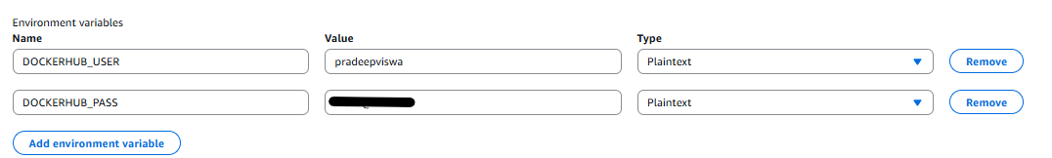

Buildspec: Use a buildspec file
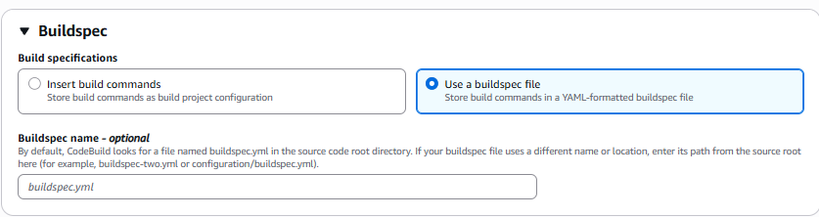
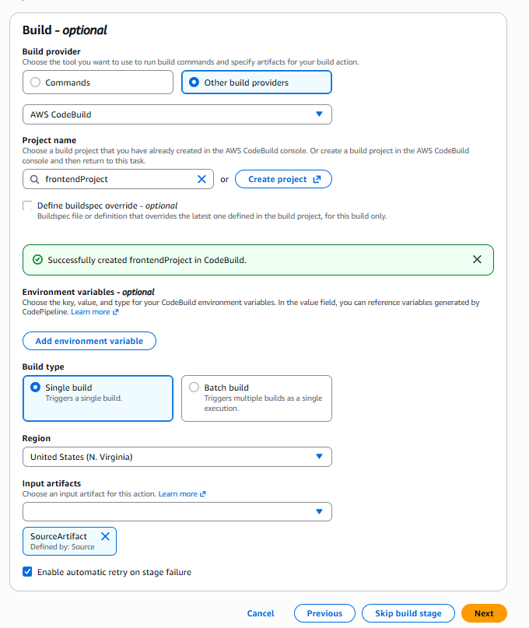

Test Stage : Skip
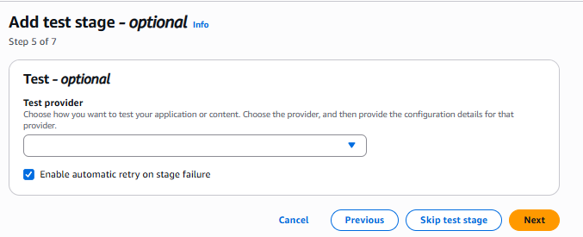

Deploy stage
Deploy provider: Amazon ECS
Input artifacts: BuildArtifact
Cluster name: ECS cluster name
Service name: frontend-service
Image definitions file : “builddefinition.json” (for frontend pipeline)
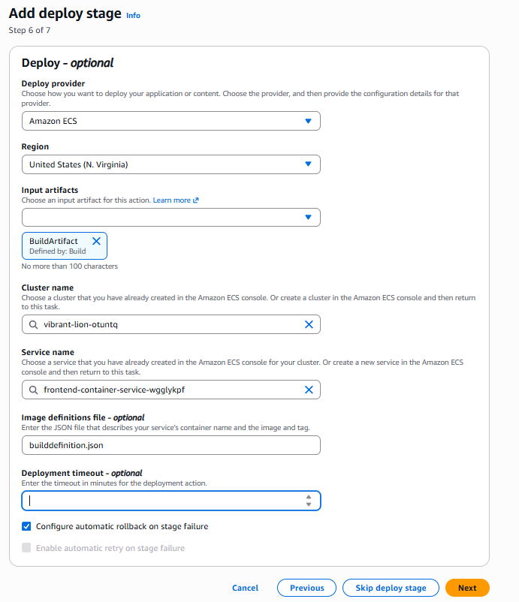

Build pipeline
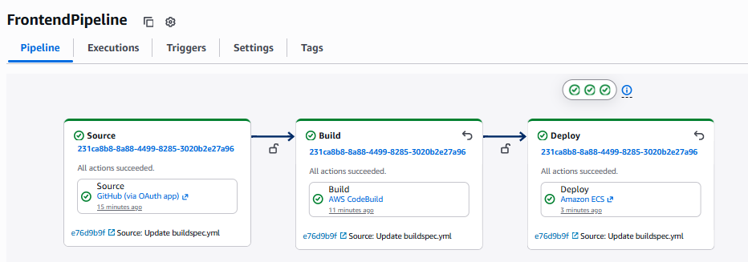

Image has been uploaded to docker-hub
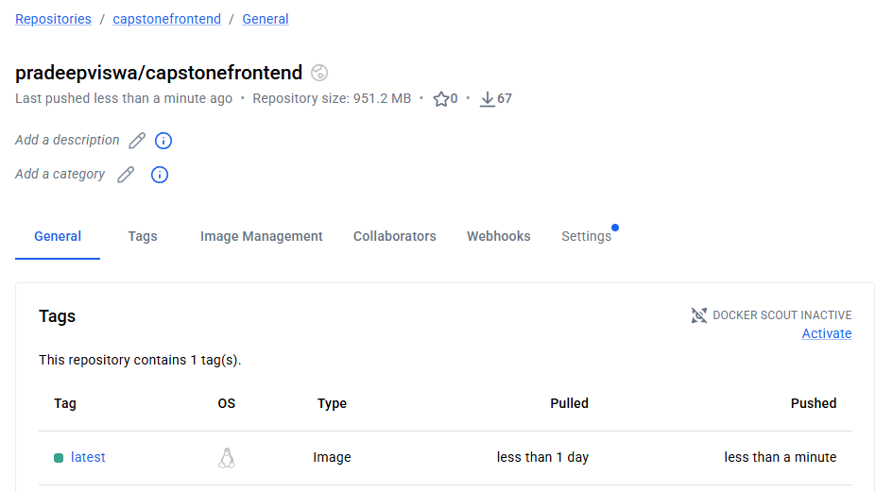

Web page
Go to cluster > service > service name (frontend-container-service-4fcey4yx)
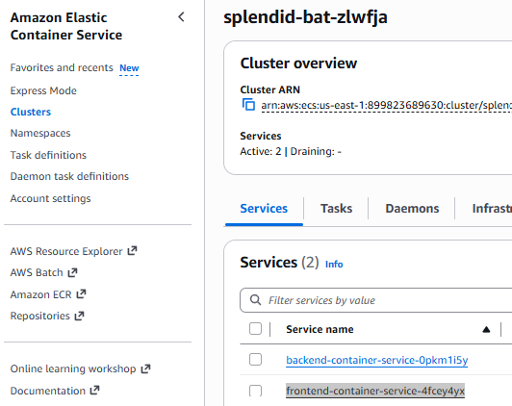
Task > click on task link
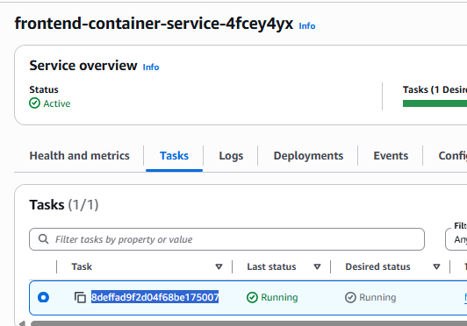

Copy public IP
Web page URL
http://34.201.70.106:3000/testAPI
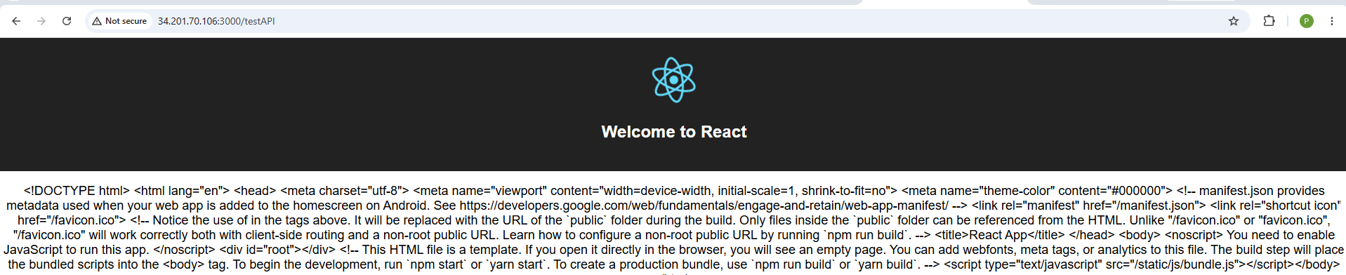

Create Code pipeline for Backend

Most of the steps are same as frontendPipeline, only difference screen shots mentioned below
Pipeline name: BackendPipeline
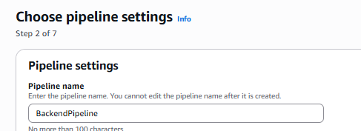
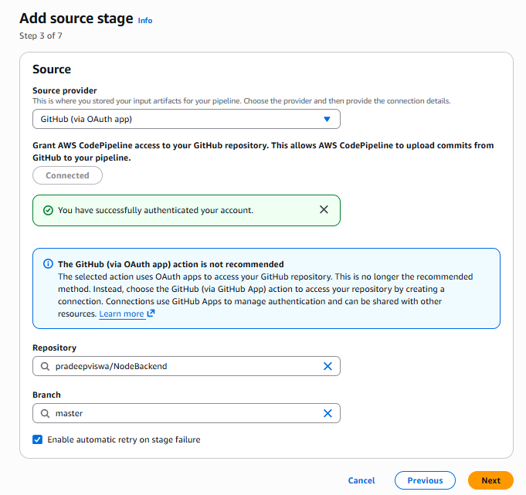

Project Name: BackendProject
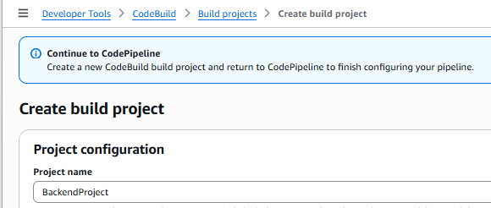
Create: “DOCKERHUB_USER” and “DOCKERHUB_PASS”
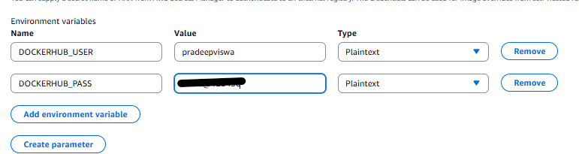
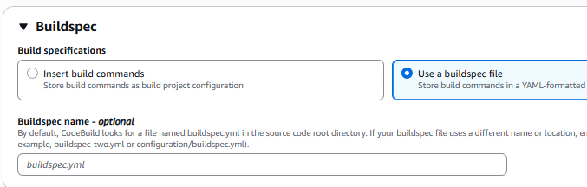
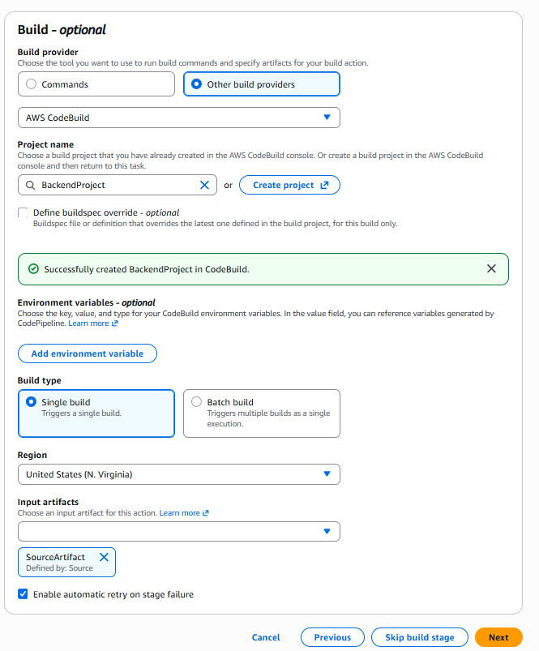

“imagedefinition.json”(for backend pipeline)
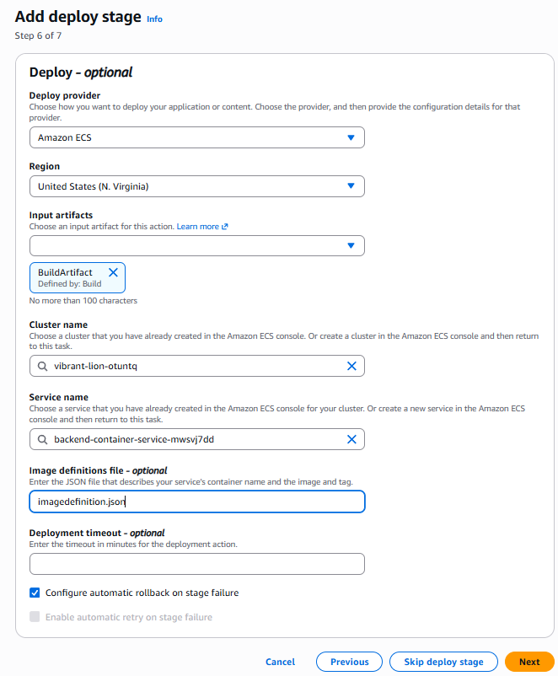

Pipeline
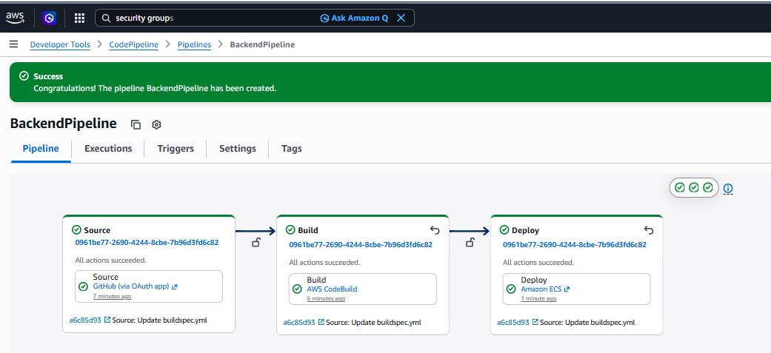
Docker image updated
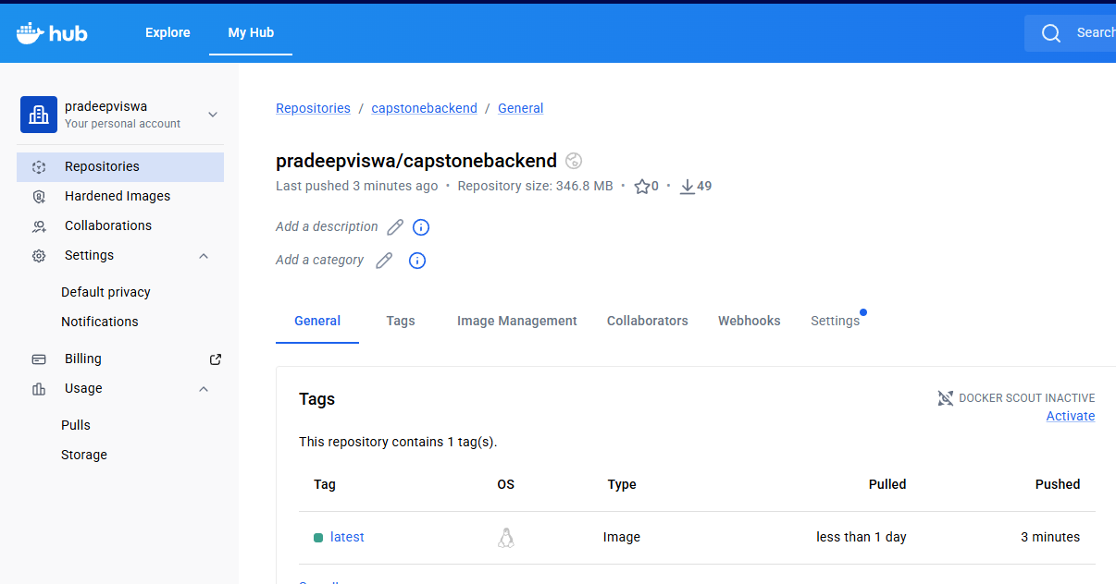

Get backend public IP from ECS cluster
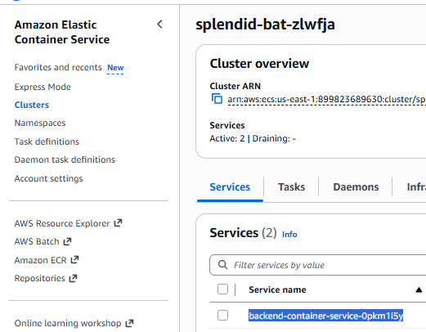
Web Page
IP is 52.91.231.121
URL: http://52.91.231.121:3000/testAPI
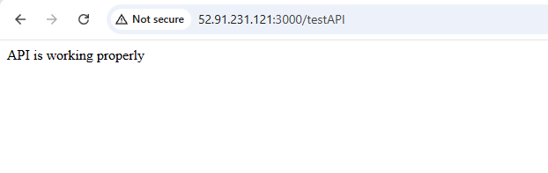

Point Frontend to correct Backend
In frontend source code, we need to modify the .env file where the backend API URL will be updated. get the correct IP address of the backend task, and update the URL
- File: ReactFrontend/.env
- file content:
  - APIURL="http://<backend-IP-Addredd>:3000/testAPI"
http:// 52.91.231.121:3000/testAPI
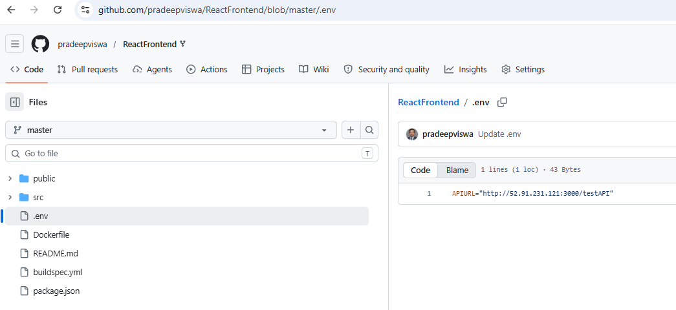

After commit build pipeline will trigger again, once done, browse frontend webpage again
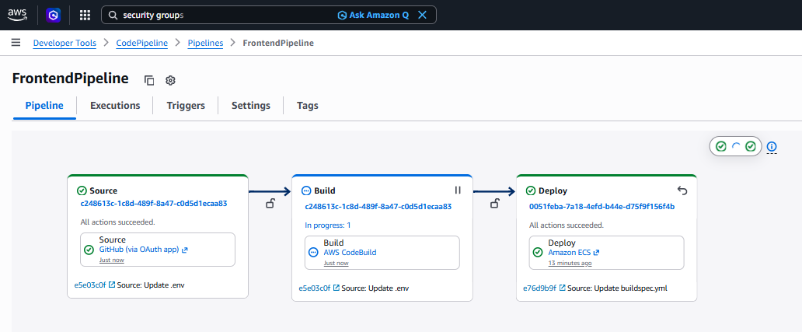
After new build, public ip of frontend has changed

Browse frontend webpage again
URLs:
Frontend: http://3.95.187.168:3000/testAPI
Backend: http://52.91.231.121:3000/testAPI

Browse Frontend again
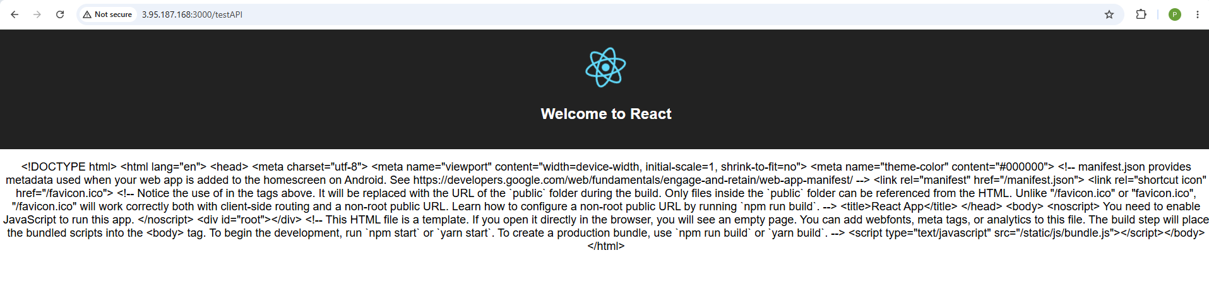

API communication is failing because of some bug in nodejs code which has to be handled by application developer team. From DevOps point of view, CI/CD pipeline is working as expected.

